

LAB REPORT
CSE232: Compiler Design Lab

02
[Report Number]

Topic: Write a Flex program to recognize the following types of strings.

Submitted To
Mushfiqur Rahman Chowdhury (MRC)
Lecturer
Department of CSE, Daffodil International University

Submitted By
Student ID: 0242220005101781
Section: 63 N
Student Name: SHAHARIAR HOSSAIN

Date of Assignment Distribution: 10 November 2025
Date of Assignment Submission: 22 November 2025

Experiment No: 02 |  | Mapping: CO1 and CO2
Experiment Name | Write a Flex program to recognize the following types of strings.
Experiment Details:
Write a Flex program to recognize the following types of strings:
❖ Strings that consist of one or more occurrences of 'x'. [x+]
❖ Strings that consist of one or more 'x' followed by one or more 'y'. [x+y+]
❖ Strings that match exactly 'x', 'y', 'z' in that order. [xyz]
Lexer.l:

%{
#include <stdio.h>
#include <stdlib.h>

/* Declarations used when scanning a string with Flex */
extern FILE *yyin;
/* Use the scanner's buffer type (defined in generated lex.yy.c). */
struct yy_buffer_state;
extern struct yy_buffer_state *yy_scan_string(const char *);
extern void yy_delete_buffer(struct yy_buffer_state *);
%}

%option noyywrap

%%

x+ { printf("Matched: %s (One or more 'x')\n", yytext); }
x+y+ { printf("Matched: %s (One or more 'x' followed by one or more 'y')\n", yytext); }
xyz { printf("Matched: %s (Exactly 'x', 'y', 'z' in order)\n", yytext); }

.|\n { /* Ignore any other characters or newlines */ }

%%

int main(int argc, char *argv[]) {
if (argc > 1) {
/* Try opening argv[1] as a file first. If that fails,
treat argv[1] as a literal input string. */
FILE *f = fopen(argv[1], "r");
if (f) {
yyin = f;
yylex();
fclose(f);
} else {
YY_BUFFER_STATE bp = yy_scan_string(argv[1]);
yylex();
yy_delete_buffer(bp);
}
} else {
/* No argument: read from stdin */
yylex();
}
return 0;
}

tests.txt:
x
xxx
xy
xyyy
xyz
xxyyy
xxyz
xyzzz
abc
def
xxy
xxxyyy
xyzabc
yyy
zzzz

Command:
flex lexer.l
clang lex.yy.c -o lexer
./lexer tests.txt # File argument
./lexer < tests.txt # stdin redirect
./lexer
Obtained Output:
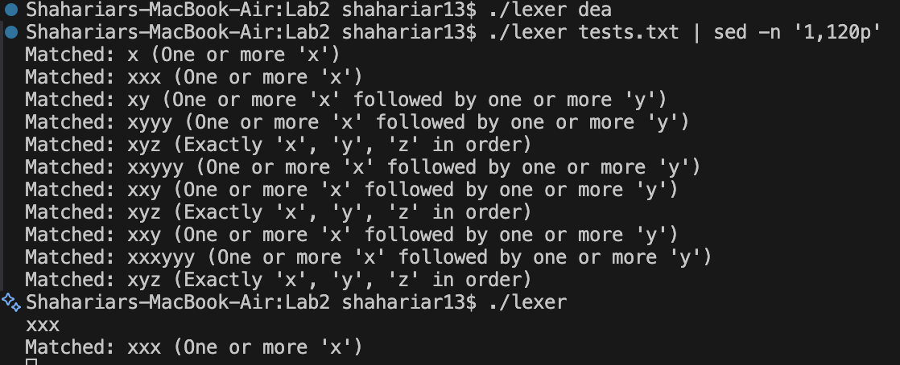 | Desired Output?
 | YES
Alternative Steps/Solution (If any):
I have implemented a Flex lexer that can take an input file or command-line string and recognize the patterns 'x+', 'x+y+', and 'xyz'.
Observation/ Comments:
The Flex lexer successfully identifies the patterns 'x+', 'x+y+', and 'xyz' from both input files and command-line strings, demonstrating its ability to process different input formats and recognize the specified patterns.
Appendix A: Course Outcomes, Complex Engineering Problems (EP) and Complex Engineering Activities (EA) Addressing.

Table: CSE312 Course Outcomes (COs) with Mappings
COs | CO Statements | POs | Learning  Domains | Knowledge  Profile | Complex  Engineering  Problem | Complex Engineering  Activities
CO1 | Demonstrate a comprehensive understanding of fundamental database management concepts, including the relational data model, normalization techniques, and SQL basics. | PO1 | C2  A2  P2 | K2  K3  K4  K8 | EP1  EP4
CO2 | Design, implement and optimize relational databases, incorporating advanced SQL queries, indexing techniques and query optimization strategies. | PO3 | C3  A3  P3 | K2  K3  K4  K6  K8 | EP1  EP2  EP7 | EA3
CO3 | Understand and Analyze security measures, distributed database architectures and emerging trends in database management, demonstrating an understanding of the broader context and challenges in the field. | PO5 | C4  A4  P3 | K6 | EP4

Table: Addressing CO (1 to 3), Knowledge Profile (K), Attainment of Complex Engineering
Problems (EP):
SN | Engineering Problem (EP) Definition | Attain  Ment | CO | Justification  (with Knowledge Profile)
01 | EP1: Depth  of  Knowledge  required | Yes/No | CO1, CO2
02 | EP2: Range  of  Conflicting  Requirement  s | Yes/No | CO2
03 | EP4:  Familiarity  of Issues | Yes/No | CO1, CO3
04 | EP7:  Interdependence | Yes/No | CO2

Table: Addressing COs
SN | COs | Attainment | Justification
01 | CO1 | Yes/No | These Lab activities attain CO1 by.
02 | CO2 | Yes/No | N/A
03 | CO3 | Yes/No | These Lab activities attain CO3 by.

Table: Lab-Wise Recommended Topics

Lab Class No. | Proposed Activity
Lab 1 | Write a Flex program to recognize the following types of strings.
Lab 2 | Write a Flex program to recognize the following types of strings.
Lab 3 | Write a calculator using Flex and Bison that supports

